Prac 10

10 a)

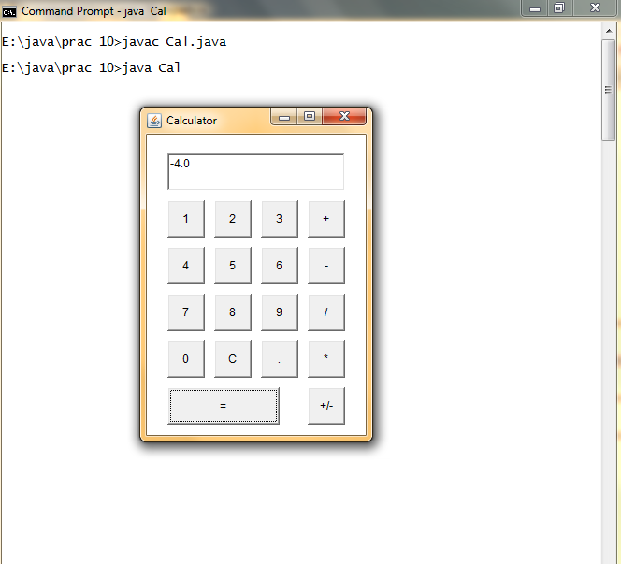

10 b)

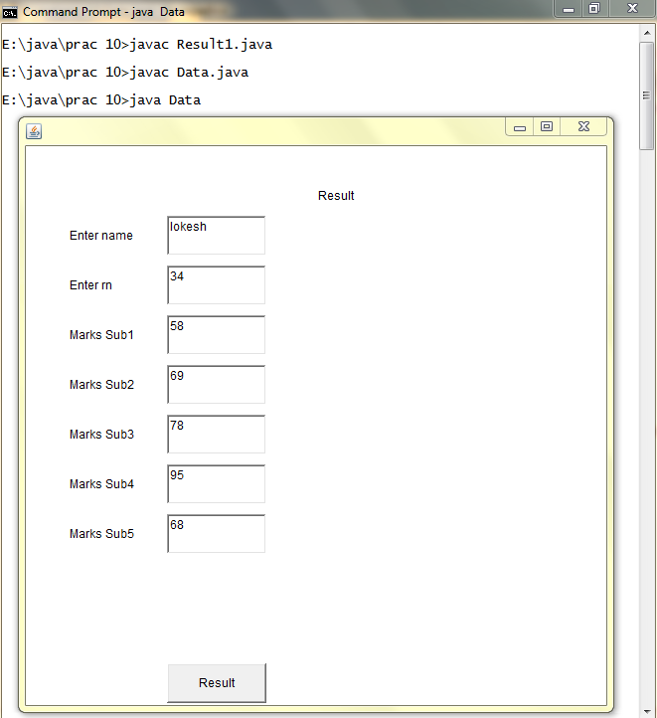

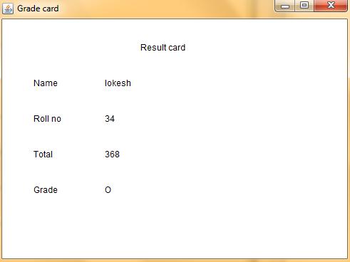

10 c)

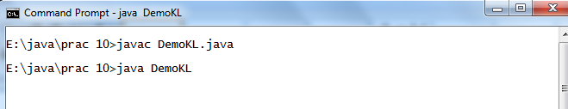

|  |  |
| --- | --- |
| Text Pressed | Text Typed |
| Text Released | |

10 d)

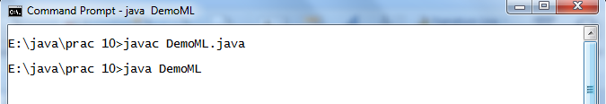

|  |  |
| --- | --- |
| Mouse Entered | Mouse Typed |
| Mouse Released | Mouse Exit |

10 e)

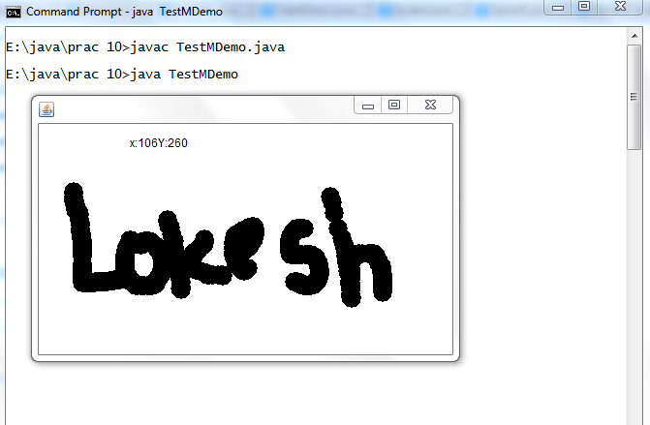

10 f)

